Lesson 8
Trigonometric Equations

sPECIFIC OBJECTIVES:
At the end of the lesson, the student is expected to:
- Define conditional equations.
- Find exact solutions to trigonometric equations.

8.1 Trigonometric Equations
Definition 8.1 Trigonometric Equations

Equations that involve the trigonometric functions are called Trigonometric Equations

Remarks:

Solving a trigonometric equation means the same thing as solving an algebraic equation, namely, finding the values of the variable that satisfy the equation. To solve trigonometric equation, we use the same techniques used in solving algebraic equations such as isolating the variable, collecting like terms, and factoring. In addition to these techniques, we can also simplify the equation by substituting trigonometric identities.

8.2 Guidelines in Solving Trigonometric Equations

- If the equation contains one function of a single angle, use algebraic technique to solve for the angle.
- Solve a quadratic equation containing a single function of the same angle by factoring. Otherwise, use quadratic formula.
- If the equation contains several functions of the same angle, substitute trigonometric identities to obtain a single function.
- If the equation contains several angles, substitute trigonometric identities to obtain a function of a single angle.

Example 8.2 Find the exact solutions to each equation for the interval 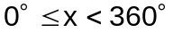.

a) 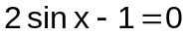 Ans. 30° and 150°

b) 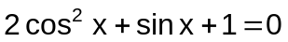 Ans. 270°

Exercise 8.2 Find the exact solutions to each equation for the interval 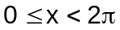.

1. 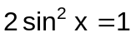

2. 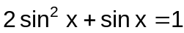

3. 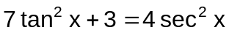

4. 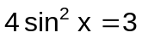

5. 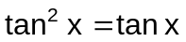

6. 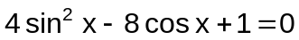

7. 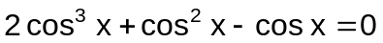

8. 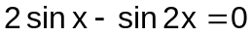

9. 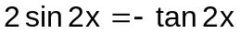

10. 